ETL Project Report:

By: Nishant, John and Anam

**Pre-Processing**

Data analyst is very demanding role. As part of project requirements our team has been hired to analyze data scientist data to address whether data scientists are very demanding or not with location.

The following table illustrates the observations and actions taken by the group to ensure a clean data set.

| **Pre-process Step** | **Data Need** | **Observation** | **Action** |
| --- | --- | --- | --- |
|  | 1000+ rows of data needed | Data well observed and relevant to each source | Two csv files |
|  | Unique identifier | Job Location is the unique identifier for two of the data sets. | Job Location – Primary key |
|  | Verified formats of data and availability of all rows | Job Location, Job title, Salary, and Job class data | Perform data cleaning and keep only necessary columns. |
|  | Config.py | Add postgres username and password | Add with. gitignore |
|  | Project Proposal | Add all requirements, Data sources and brief descriptions about project | Project proposal is added to GitHub |

**Extraction**

We used 2 different datasets from the public platform Kaggle which led us to the Data science job opportunities and Data science job listings. The data in the two files included the following information:

* Data science job opportunities
* Data science job listings

The fields of interest include the following:

* Job location
* Job title
* Salary
* Job class

The following sources for our datasets used:

<https://www.kaggle.com/datasets/nadzmiagthomas/australia-data-science-jobs>

<https://www.kaggle.com/datasets/nomilk/data-science-job-listings-australia-20192020>

**Transformation**

To transform the public data and use it in our study we performed the following:

* Used Pandas functions in Jupyter Notebook to load all two CSV files.
* Reviewed the files and transformed into data frames.
* We used Pg admin to create table.
* Removed the unnecessary columns as part of data cleaning and keep only three columns (Job location, Salary, and Job title) in data science job opportunities datasets.
* Removed the unnecessary columns as part of data cleaning and keep only two columns (Job location and Job type) in data science job listings data set.
* Identified duplicates by doing an inner merge on the Job Location column across all two data sets.

**Data science:**

job_location job_title salary

0 Melbourne Analyst 95917

1 Mulgrave Clinical Research Associate 96555

8 Australia Software Engineer 212000

40 Dandenong Quality Manager 90000

44 Reservoir Food Technologist 75000

**Job listings:**

job_location job_class

0 Sydney Science & Technology

1 ACT Information & Communication Technology

8 Melbourne Information & Communication Technology

15 Perth Information & Communication Technology

24 Brisbane Mining, Resources & Energy

**Load**

After we pulled in the CSV files and loaded them into the data frames, we did an initial connection to the Postgres database using PG admin to store our original clean data sets. We used the quick database website to create the initial table schema that got loaded into the Postgres database that generated the first set of tables. After running the queries and created the new tables with only the relevant information we reconnected to the database and generated additional tables for the data frames.

**Joining of data science and job listings:**

job_location job_title salary job_class

0 Sydney Data Scientist 125000 Science & Technology

1 Melbourne Analyst 95917 Information & Communication Technology

2 Perth Entry Level

Media Coordinator 65520 Information & Communication Technology

3 Brisbane Graduate

Data Scientist 128589 Mining, Resources & Energy

4 Darwin Data Manager 82988 Science & Technology

5 Adelaide Software Engineer 85000 Science & Technology

6 Hobart Biostatistician 106500 Science & Technology

7 Gold Coast Data Engineer 82171 Information & Communication Technology

**Postgres Database:**

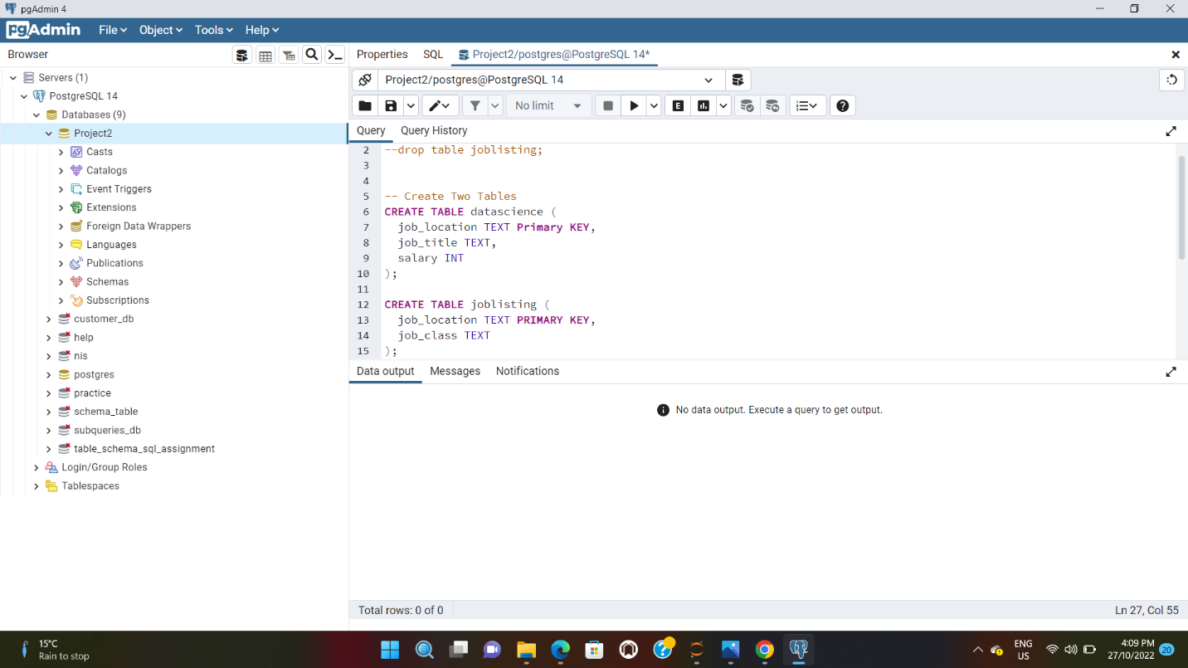

**Summary**

There were some limitations to our findings due to the data available and limited time. However, we were able to address some relevant questions in our initial project proposal below:

The data science job is very demanding role across Australia as it offers higher salary and a huge number of opportunities.

Questions: Is it worth to be a Data scientist in Australia?

Findings: Yes, Data science is very popular job profile in Australia as it offers higher salary. Here in this analysis, we found data scientist making more than 90000$ per annum. Moreover, we can also able to see that job opportunities are very huge as per the data available for each job location.

Questions: Which Job class are popular in Australia as Data scientist?

Findings: Here in Job listings, we can easily be able to conclude that Information & technology is very popular job class in not only Australia but also in major states of Australia. Moreover, data analyst from this similar job class makes higher annum salary.

Questions: Which job titles getting highest annum salary?

Findings: Based on the analysis, Software engineer makes highest salary with more than 200000$ and they belong to the science and technology job class.